McDonalds Public RElations Campaign:  Healthy Living and Healthy Choices at McDonalds | Abstract  Despite all of the media claims implicating fast food as a major factor in the nation’s current obesity epidemic, this PR campaign will demonstrate and emphasize the healthy options that are available at the nation’s #1 fast food retailer, McDonalds.  David Thomas  PR Management

Organizational Overview
McDonald’s was founded by brothers Mac and Richard McDonald, who implemented a system emphasizing speed, volume and low prices. The first modern McDonalds restaurant opened in 1948; however the first McDonalds franchise was started by Ray Croc in 1955 in Des Plaines, Illinois. This marked the start of the McDonalds Corporation. Kroc purchased the rights to the chain in the early 1960s and moved to expand the number of franchises. “Kroc emphasized the idea of fast, low-priced, quality products offered in a clean, friendly environment.” (Biswas, 2006)

The McDonalds Corporation is truly an American success story, a classic example of the American entrepreneurial spirit. Currently the world’s largest restaurant chain, McDonalds serves over 69 million customers in over 100 countries on a daily basis. The restaurant chain has become so ubiquitous, it is hard to imagine a world without it. McDonalds has also come to be synonymous with convenience and synonymous with the modern age. Perhaps because of its monolithic success, it becomes an easy target on which to pin the blame for some of modern society’s chronic ills.

It is no revelation to note that we live in a microwave society of instant access and instant gratification. Typifying the rise of the modern technological state is an almost global reliance upon and addiction to fast food. For modern consumers and families, taking a trip to a fast food restaurant is not a treat but a daily occurrence. Coinciding with the rise in popularity of the fast food industry has been a global rise in obesity rates. Currently, the nation’s obesity rate stands at 39.6% for adults age 20 and older and 17% for children and adolescents, epidemic numbers (Hales, 2017). Many people point the blame for the nation’s obesity epidemic at the nation’s fast food industry. The paradox of the entire situation is that while Americans acknowledge the need to diet, to eat healthy and to exercise, we have become a nation addicted to convenience. Every household contains at least one microwave oven. Furthermore, fast food is not just indulged in by certain segments of the population but by consumers from every age group and socioeconomic demographic.

Situational Statement
McDonalds, as the number one fast food retailer, has been targeted in the media along with the entire fast food industry as a major contributor to the nation’s obesity crisis. McDonalds needs to be able to counter this claim by demonstrating that in addition to menu items which contain high numbers of calories, and high fat and sugar content, McDonalds also contains healthy menu items that are relatively low in calories, fat and sugar. In essence, it is possible to eat healthy at McDonalds.

SWOT Analysis
An analysis of the chain’s strengths and weaknesses reveals the following;
Strengths
- Convenience
- Speed
- Customer service
- Pervasive locations
- Cleanliness
- Affordability
- Taste
- Diverse menu options
Weaknesses
- High fat and sodium content for many of the menu items.
- High sugar content in many of the beverages.
- Mixture of healthy and unhealthy menu items.
- Until recently, lack of upscale offerings

Opportunities
- Showcase healthy menu options.
- New gourmet sandwich offerings
- Tailored marketing to millennials.
- Competing with more upscale burger establishments.

Threats
- New municipal sugar taxes
- Documentaries like Fast Food Nation and Super Size Me assigning blame for obesity
epidemic at the fast food industry.
- Competition from gourmet burger establishments (e.g. Five Guys).

Key Publics
Millennials – High digital literacy and social media engagement. Value convenience, price, and customer service.

Young families with children - Don’t have to cook, quick, easy, and affordable. Safe, fun, menu items and amenities appealing to kids – playgrounds, coloring pages, bright engaging happy meals, toy prizes.

Inner city, urban dwellers: Convenience, placement of stores in downtown areas. Reasonably priced items.

Commuters/People on the go: Priorities: Proximity to businesses and commercial areas, speed of service. Businesspersons value prestige and image. May be open to upscale sandwiches.

Key Findings
- There is a need for renewed digital marketing and public relations campaigns to target the millennial demographic. The millennial consumer is better engaged through social media than the traditional ad campaigns of the past.
- Children and families with kids is a very important demographic for McDonalds. This demographic should respond well to healthy lifestyle and educational initiatives.
- Businesspersons are potentially interested in more upscale offerings at an advanced price point.

Campaign Goals
The overall goal of the campaign is to promote and make the public aware of McDonald’s healthy menu options. This is both an awareness campaign as well as a health education initiative. We are looking to change the public’s association of McDonalds with obesity and unhealthy lifestyles to being endorsers and promoters of personal transformation.

Campaign Objectives
- 17 million consumers will be exposed to the Healthy Lifestyles campaign via television, print, billboards, social media, and in-store promotional materials.

- We are looking to have at least 250,000 entrants into the McDonalds Healthy Lifestyles Contest.

- We are looking to garner 500,000 social media engagements across the various social media channels.

- We are looking to increase sales of items on the Healthy menu by 3%.

- Children in over 10,000 schools across the nation will be introduced to the McDonalds Healthy Lifestyles nutrition education program.

- We are looking to shift public perception of McDonald’s commitment to health promotion by 6%.

Campaign Strategy
The McDonalds Healthy Lifestyles campaign will be comprised of both a multimedia campaign encompassing (television, print and social media) as well as an education component targeting the nation’s schools.
Program Elements
- Celebrity endorsements: Recurring television spots and social media ads featuring The Rock and Jillian Michaels. (Expense: $500,000)

- McDonalds Healthy Lifestyles Transformation Contest
The contest is to be promoted via social media (Instagram, YouTube, Twitter and Facebook). Contest entrants must detail how they are incorporating McDonald’s healthy menu items in their personal transformations and/or how the healthy menu items are being used to maintain a fit, healthy lifestyle. Entrants may post Before and After pictures, written and video testimonials via the link provided. After review, entries will be posted on the McDonalds YouTube channel. Four winners who embody the McDonalds Healthy Lifestyle ethic will be featured in national television ads and receive a $50K cash prize each. (Expense: $240,000)

- McDonalds Healthy Lifestyles Education Initiative
Teams of five persons in each state over the course of a year will reach out to individual schools and school districts to introduce the McDonalds Healthy Lifestyles Nutrition Education Program. McDonalds will make the curriculum and learning materials available to schools and districts. The nutrition education program in addition to educating students about the food pyramid and the basic four food groups will show students how to make healthy menu choices at McDonalds. Students will learn about calories, portion sizes, the importance of eating a healthy breakfast, and more. In addition to nutrition, the program will emphasize the importance of exercise and maintaining an active lifestyle. McDonalds’ goal is to introduce the program into at least 200 schools in each state over the course of a year. (Resources: 250 persons nationwide. Budget: $1 million)

Key Messages/Slogans
Healthy Living, Healthy Choices – McDonalds
Good food, Good Times, Good for you
Make The Choice! – McDonalds Healthy Choices Menu
Eat Responsibly – McDonalds Healthy Choices Menu

Sample Images and Messaging

When I’m on the go, McDonalds is my go to place for some lean, mean protein.

Make McDonalds part of your healthy lifestyle.

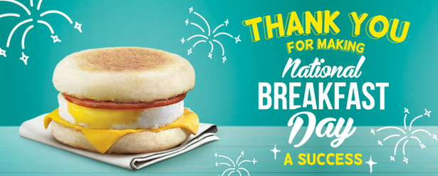
The Egg McMuffin, an American classic and only 290 calories.

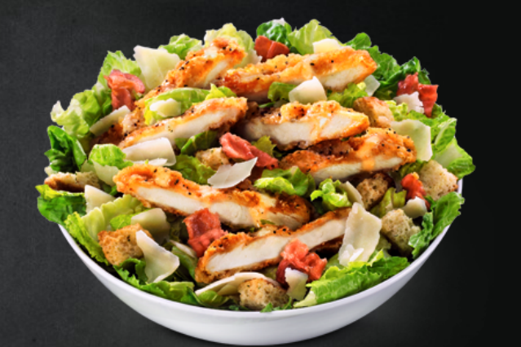
Try a McDonald’s salad today. You’ll love how it looks on you.

Evaluation Metrics
- Television ad views will be tracked by Nielsen. Nielsen will provide the time of airing of the ads, on which shows they appeared, the number of viewers and viewer demographics.
- We will utilize social media analytical tools to track the number of engagements.
- We will be able to track the number of contest entrants from the website submissions.
- Sales revenues of healthy menu items will be tracked in the corporate headquarters.
- Numbers of school partnerships and number of schools employing the healthy lifestyles nutrition education program will be compiled from each state’s field team.
The goals of the public relations campaign are both qualitative as well as quantitative. It will be easy to track the number of persons being exposed to the multimedia campaign. It is also straightforward to track the number of schools engaging in the nutrition education initiative as well as the number of contest entrants. However, in order to measure whether public attitudes regarding McDonalds and healthy lifestyles have changed, we will employ customer surveys both on our Facebook page as well as on the contest website soliciting public feedback. The surveys will be initiated prior to the start of the campaign and continue throughout the campaign’s duration so that we can evaluate whether the campaign is affecting the public’s view of us. Feedback from parents of students attending schools that are participating in the nutrition initiative will also be collected.

Summary
Because McDonald’s has been associated for so long with low cost food offerings, people have come to associate the fast food chain with low-quality, non-nutritious, junk food. It is definitely going to be a struggle to revamp the restaurant’s image. In McDonald’s case, facts and perception do not always coincide. The movies from the early 200s, Fast Food Nation and Super Size Me, left an indelible impression upon many in the the public. Accusations of the retailer utilizing pink slime and not actual meat still follow McDonalds. The reality is that the chain utilizes 100% real beef in its burgers, hoki fish in its fillet of fish sandwiches and genuine chicken in its McNuggets and chicken sandwiches. According to CEO Don Thompson, “The produce and the products that we have at breakfast and across the menu are fresher than — no disrespect intended — what most of you have in your refrigerators.” (Associated Press, 2014)

While it is undeniable that there are many items on McDonald’s menu which contain high amounts of sodium, fat, and/or sugar, it is also true that contrary to popular belief, there are a number of nutritious, low calorie, low fat offerings which McDonalds has included on its menu. Some long standing menu staples like the Egg McMuffin are actually among the industry’s healthiest breakfast sandwiches. There are quite a number of menu offerings under 500 calories including the hamburger, cheeseburger, 10-piece chicken McNuggets, and the Premium grilled chicken sandwich just to name a few. Even the Big Mac and Quarter Pounder with cheese only weigh in at 540 calories respectively. The task before McDonalds is to reeducate the public and to demonstrate that it is possible to eat healthy in its restaurants. Lastly, the campaign would demonstrate that McDonald’s actually cares about the health of its customers by undertaking to show those who are interested how to eat healthy meals at the restaurant.

America was founded on the notion of protecting freedom and the right to choose. And like America, McDonalds does not dictate to consumers how they must eat but rather provides the options to eat healthy or not. Fast food is here to stay. It is a fixture of modern life. Our busy, hectic lifestyles oftentimes necessitate that we frequent fast food establishments. It’s good to know that we don’t have to succumb to unhealthy menu offerings when we frequent these establishments.
Feel good about yourself. McDonalds and you.

References
Biswas, S. (n.d.). Public relation and mcdonalds as an example. Retrieved from https://www.scribd.com/doc/49466203/public-relation-and-mcdonalds-as-an-example
Drayer, L. (2017, January 27). McDonald's Best Menu Picks, by a Nutritionist. Retrieved from http://www.cnn.com/2017/01/27/health/mcdonalds-menu-nutritionist-food-drayer/index.html
Fitzpatrick, J. (2009, June 08). Five Healthiest Foods at McDonald's. Retrieved from https://lifehacker.com/5283646/five-healthiest-foods-at-mcdonalds
Frank, J. N. (2004, January 05). McDonald's emphasizes PR in new marketing strategy. Retrieved from https://www.prweek.com/article/1247010/mcdonalds-emphasizes-pr-new-marketing-strategy
Frey, M. (2017, August 22). What to Eat at McDonald's for 500 Calories or Less. Retrieved from https://www.verywell.com/mcdonalds-fast-food-meals-under-500-calories-3495690
Hales, C., MD, Carroll, M., MSPH, Fryar, C., MSPH, & Ogden, C., PhD. (2017). Prevalence of Obesity Among Adults and Youth: United States, 2015–2016. National Center for Health Statistics Data Brief, (288).
Jones, E. (2017, July 13). 9 of the healthiest things you can order in McDonalds. Retrieved from http://www.cosmopolitan.com/uk/body/health/news/a46171/healthiest-thing-you-order-mcdonalds/
McDonald's Nutrition Calculator | McDonald's. (n.d.). Retrieved from https://www.mcdonalds.com/us/en-us/about-our-food/nutrition-calculator.html
Morrison, M. (2015, March 23). McDonald's Launches 'Moments of Joy' in 24 Cities in 24 Countries on March 24. Retrieved from http://adage.com/article/cmo-strategy/mcdonald-s-launching-global-effort-brand-refresh/297722/
Overweight & Obesity Statistics. (2017, August 01). Retrieved from https://www.niddk.nih.gov/health-information/health-statistics/overweight-obesity
Press, A. (2014, August 18). McDonald's tries to change its image from 'fast food' to 'good food served fast' with fruit, egg-white McMuffins and its first menu item ever to contain cucumber. Retrieved from http://www.dailymail.co.uk/news/article-2727939/McDonalds-confronts-junk-food-image.html
Starkman, N. (2014, October 13). McDonald's Launches 'Our Food, Your Questions' Campaign. Retrieved from http://time.com/3501921/mcdonalds-transparency-campaign/
Sung, A. (2012, December 06). Lessons in Facebook. Retrieved from https://www.qsrmagazine.com/exclusives/lessons-facebook
Thring, O. (2013, January 29). McDonald's: A healthier, happier meal – or just good PR? | Oliver Thring. Retrieved from https://www.theguardian.com/commentisfree/2013/jan/29/mcdonalds-healthier-happier-meal-good-pr
Warren-Payne, A. (2013, July 10). 10 brilliant digital marketing campaigns from McDonald's. Retrieved from https://econsultancy.com/blog/63032-10-brilliant-digital-marketing-campaigns-from-mcdonald-s

Appendix
Additional Sample Slogans and Images
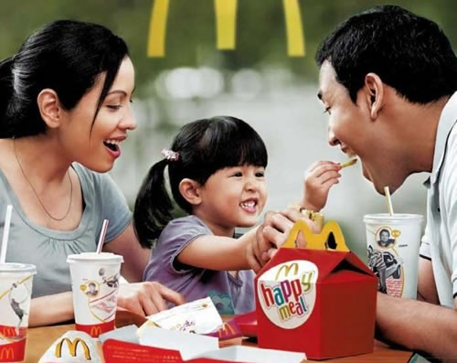
Healthy Living, Healthy Choices – McDonalds
Good food, good times… Good for you.

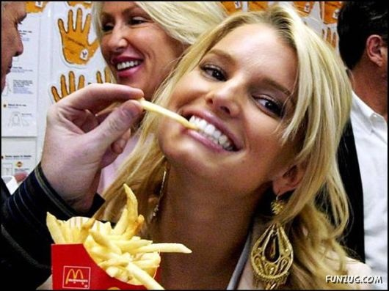
Feel good about yourself… McDonalds and you.

